ASR VW Outbound container permit check list:

Date: 28 Jan 2015

Requestor: Yeo

Request:

>> Outbound Container Permit check list

To add system check point for containers that require special treatments:

1. Add the container conditional readiness before to prepare DO (gate-pass )

- To ensure container completion of stamp, fumigation, ventilation, QC check-points.

- to update timestamp and reference number for each treatment update.

2. Container requirement setup- by Shipto ( customer master list to upload)

3. DO( gate pass) with summary indicated-

- Indicate in DO(Gate pass) - Treatment Require ( checking of Form G ( after ventilation) )

- DO indicate as "Draft copy" for incomplete Treatment Container

4. Use RF to update.

RF Update- Container treatment / QC

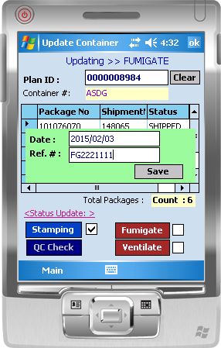

WMS changes:

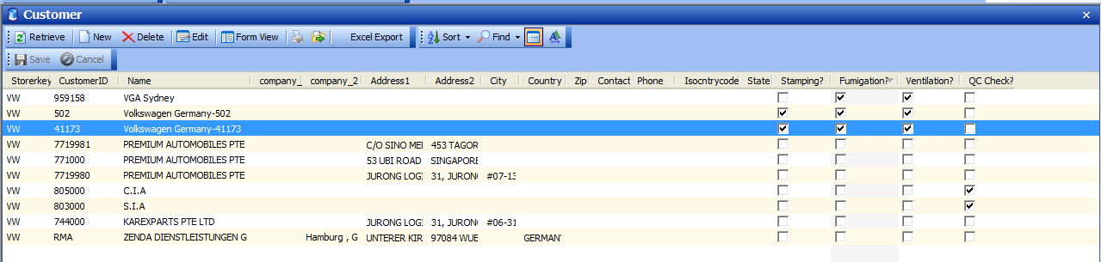

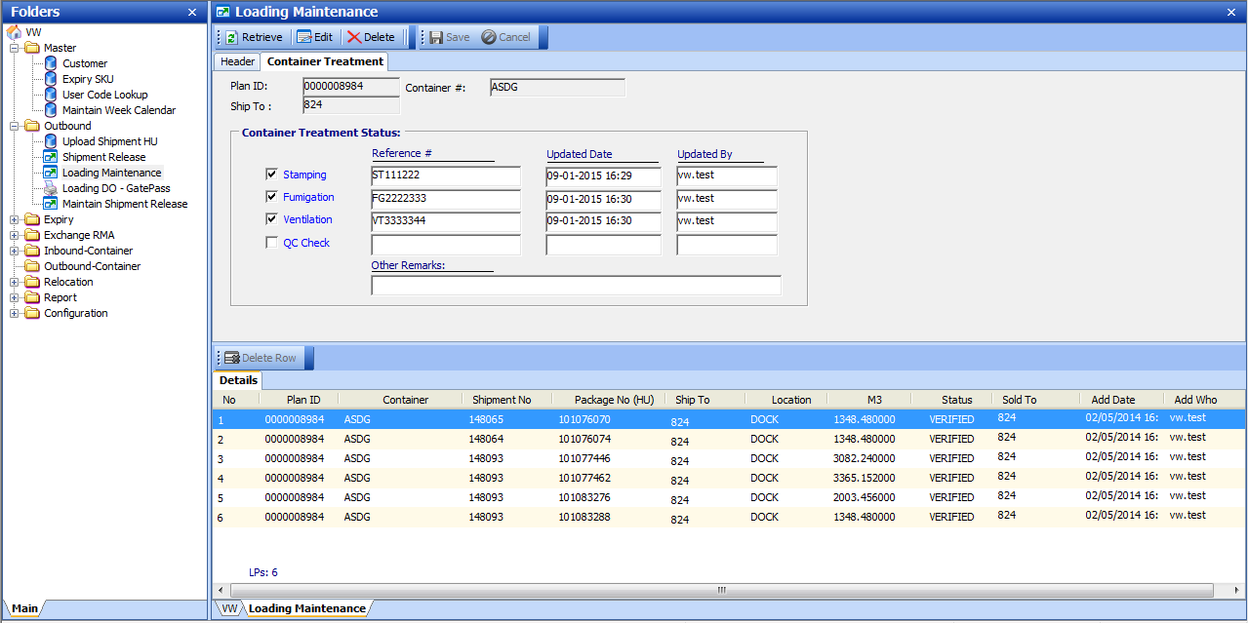

DO print out

